­­ 

Data Analytics Data Director System (DA - DDS) Environment Setup Guide

Table of Contents

General Overview 3

DDSScriptTool.exe.config Details 4

# General Overview

Environment setup exe is an automate process of executing the Staging scripts and Task Manager Script on respective databases.

Moreover, this will provide an additional feature of executing the Stored Procedures in “***STAGING***” database therefore minimizing the manual effort of running scripts.

Manual effort will be required by the user to place the ***DDSScriptTool.exe*** and ***DSScriptTool.exe.config*** (which is available in the DDS delivery package) in ***WCFSERVICE\BIN* folder** of Risk master.

Few nodes have to be set in ***DDSScriptTool.exe.config*** file before running this exe.

“***SCRIPTS***” folder available in DDS delivery package contains all the scripts (Task Manager, Staging, and Stored Procedures) to be executed. Also there is a ***DDS_SCRIPT_SEQUENCE.config*** file in “***SCRIPTS***” folder that indicates the sequence in which scripts will be executed.

**NOTES:**

1. **PLEASE DO NOT CHANGE THE SEQUENCE IN THIS *DDS_SCRIPT_SEQUENCE.CONFIG* FILE.**
2. **YOU MUST HAVE CREATE TABLES, PROCEDURES, FUNCTIONS, INSERT, DELETE, DROP ETC. PRIVILEGES ON THIS STAGING DATABASE THAT IS MENTIONED IN THE NODE “*RMXSTAGINGDATASOURCE*” OF THE CONNECTIONSTRING.CONFIG.**

# DDSScriptTool.exe.config Details

1. Mention the highlighted paths in DDSScriptTool.exe.config for “**SCRIPTS”** folder and output path.

**ClientId:**  For Multi tenant rmA environment edit this node to the value which is there in Client_id column of Client_Detail table in MTSecurity database.

**DDSScriptFolderpath**: This path refers to the location where **“SCRIPTS”** folder is placed which is provided in the DA DDS delivery package to set up the environment. This script folder will contain all the Stored Procedures, Staging scripts for both SQL and Oracle required by the DA DDS project.

**DDSScriptOutputPath**: It can be any path where DDSErrorlog.txt file as output file will be created which will indicate if any error is encountered while running the scripts or all files were successfully executed.

**DSNName:** This node is required **only if RM Express set up is used** i.e. to read the connection Strings from DA_CONFIG table instead of connectionStrings.config file.RM Express is a setup whereby multiple users are hosted on single RMA server so in order to allow them use different staging databases the connection strings file is moved to database table. If setup is non RM Express then no need to enter any value in this node.

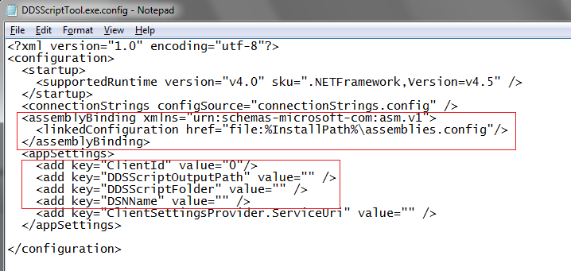

Figure1: DDSScriptTool.exe.config

1. Make sure the paths given in the first step are accessible, when you give the path in the run command box.

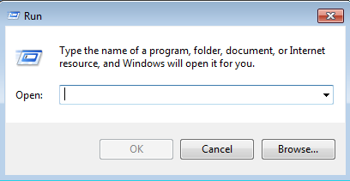

Figure2: Run Prompt

1. All the scripts must be available at the path provided in the Step 1 in the node ***DDSScriptFolder***of ***DDSScriptTool.exe.config*** file. Refer the below snapshot.

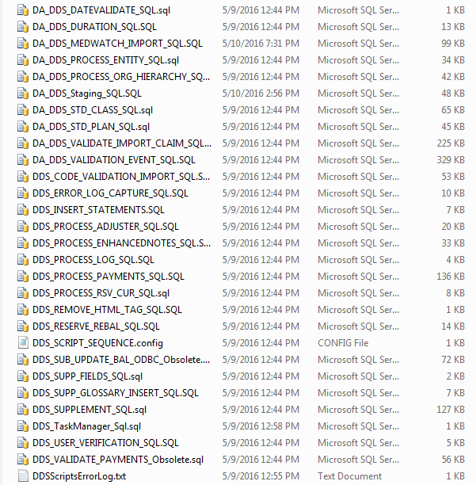

Figure3: Script folder

1. Please do not modify the ***DDS_SCRIPT_SEQUENCE.config*** file as it contains all the script names in the exact sequence in which it needs to get execute at the database. ***DDS_SCRIPT_SEQUENCE.config*** file must be available at the ***DDSScriptFolder*** path mentioned in the ***DDSScriptTool.exe.config****.*

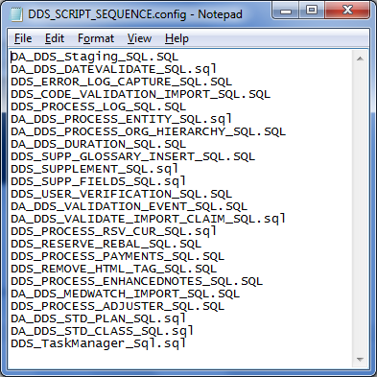

Figure4: DDS_SCRIPT_SEQUENCE.config

1. After setting up the paths in ***DSScriptTool.exe.config*** file then execute the ***DDSScriptTool.exe*** by double click on it. If paths are not given, then error will be shown on command prompt as follows.

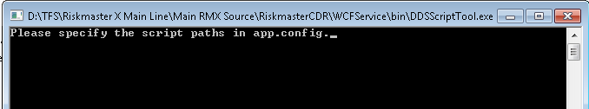

Figure5: DDSScriptTool.exe

1. If there is any error while execution, then DDSScriptsErrorLog.txt file will be created at the output path specified in the ***DDSScriptTool.exe.config****.*

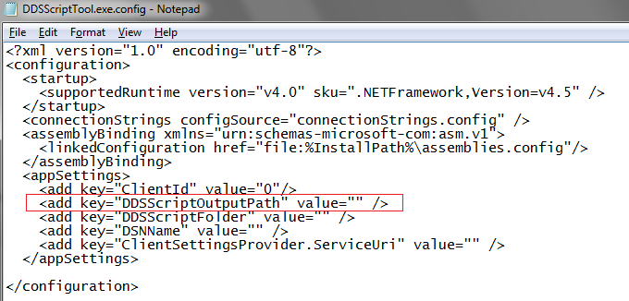

Figure6: Ouputpath in exe. Config

1. If there is an error, then following is the snapshot as an example (Figure7)

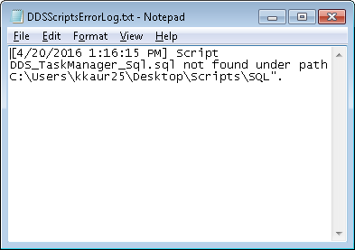

Figure7: DDSScriptsErrorLog.txt

1. Otherwise DDSScriptsErrorLog.txt file generated will indicate that all scripts executed successfully (Figure8).

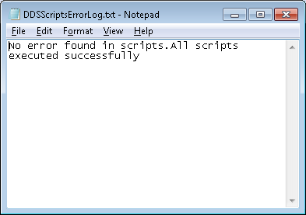

Figure8: DDSScriptsErrorLog.txt

**NOTES:**

1. **PLEASE DO NOT CHANGE THE SEQUENCE IN THIS *DDS_SCRIPT_SEQUENCE.CONFIG* FILE.**
2. **YOU MUST HAVE CREATE TABLES, PROCEDURES, FUNCTIONS, INSERT, DELETE, DROP ETC. PRIVILEGES ON THIS STAGING DATABASE THAT IS MENTIONED IN THE NODE “*RMXSTAGINGDATASOURCE*” OF THE CONNECTIONSTRING.CONFIG.**